CS 224 – LAB 4A

Memory (MEM) Stage

Student Details
- Name: TODO: Fill
- Roll No: TODO: Fill
- Group Number: TODO: Fill
- Date: TODO: Fill

Please note:
Students must be able to explain the code they submit (whether provided or written by them).
If a student cannot explain a component, marks for that component will not be awarded even if it works.
⚠ No marks will be awarded if the block diagram is not shown.

1. Block Diagram (2 marks)

Requirement
Draw the Memory (MEM) stage system of a RISC-V processor as a standalone, clocked memory subsystem.
📌 Use:
- Combinational blocks: muxes, comparators, decoders
- Sequential blocks: registers, synchronous memories
☑ Program Counter (PC)
☑ Instruction Memory (IMEM)
☑ Data Memory (DMEM)
☑ Address decode / word alignment logic
☑ Byte write strobes (wstrb)
☑ Read-after-write (RAW) forwarding muxes
☑ Clocked memory behavior
☑ Observable outputs (instruction / read data)
TODO: Paste the image of a hand drawn block diagram here

2. Timing Diagram (1.5 marks)

Minimal signals to be shown
- clk
- pc
- instr
- re, we
- raddr, waddr
- rdata, wdata

Conditions to Demonstrate
☑ One-cycle instruction fetch latency
☑ Store followed by load to the same address
☑ Correct forwarded read data
☑ Stable read data when re = 0
📌 Minimum 10 clock cycles required
TODO: Paste the image of a hand drawn timing diagram here

3. Design (2 marks)

Verilog Files Used
- memory.v

Design Description
The MEM stage:
- Fetches instructions from synchronous Instruction Memory (IMEM)
- Performs load/store operations using synchronous Data Memory (DMEM)
- Supports byte-level writes using wstrb
- Produces one-cycle-latency read outputs
- Implements byte-level RAW forwarding for same-cycle read/write
- Uses FPGA-safe, synthesizable memory constructs
- Initializes memory using external hex files
TODO: Add screenshot of your memory.v code (highlighting TODO sections)

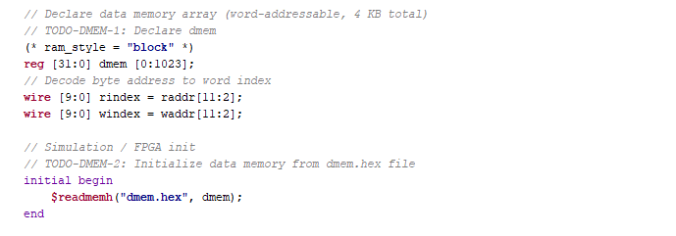

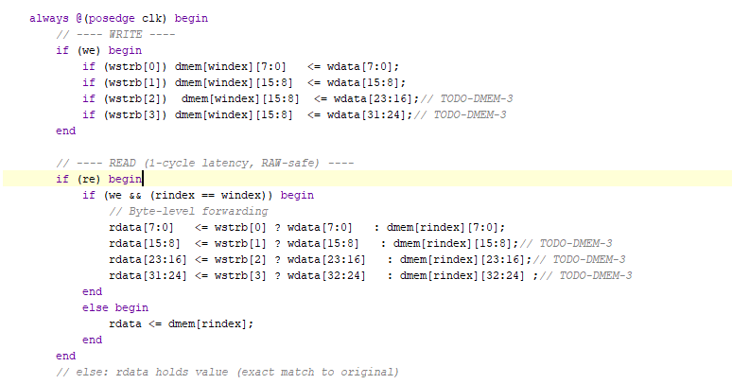

4. Validation Using Simulation (1 marks)

Testbench
- tb_mem.v

Verification Method
Trace-driven functional simulation using:
- imem.hex
- dmem.hex
Outputs logged to:
- mem_out.txt

Cycle-by-cycle validation of:
☑ Instruction fetch correctness
☑ Load and store behavior
☑ Byte-level write correctness
☑ Read-after-write forwarding
☑ One-cycle memory read latency

Result
☑ Simulation completed successfully
☑ Output trace matches expected behavior
TODO: Paste waveform screenshot here

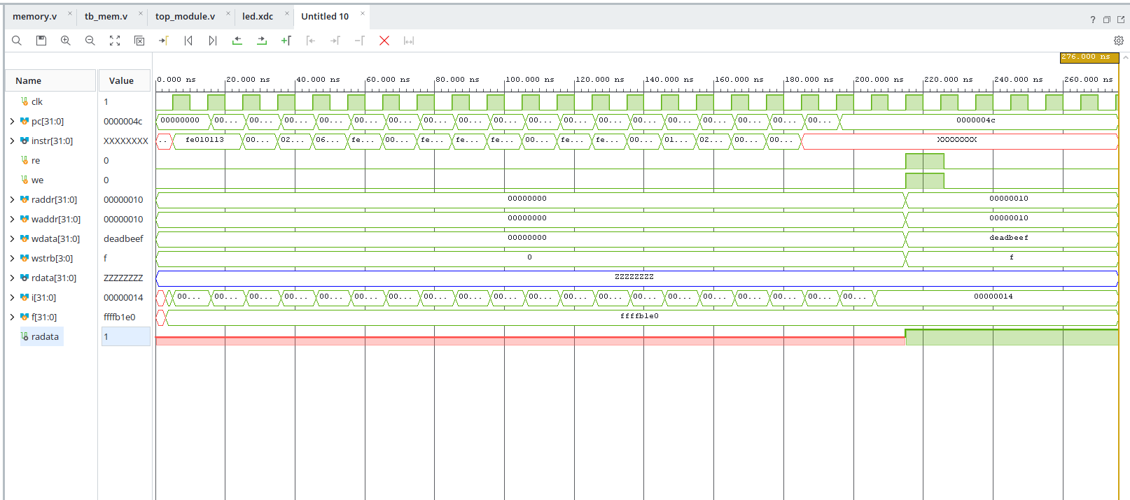

5. FPGA Demo (3 marks)

Hardware Used
- Nexys A7 FPGA Board

Files Used
- top_module.v
- memory.v
- imem.hex
- dmem.hex
- constraints.xdc / led.xdc

FPGA Mapping
- Clock → On-board 100 MHz clock
- PC input → Switches / counter
- Instruction or read data → LEDs
- Optional slow clock divider for visibility

Observation
☑ IMEM and DMEM inferred as block RAM
☑ Bitstream generated
☑ FPGA programmed
☑ Instruction fetch shows correct sequencing
☑ Load/store behavior visible on LEDs
☑ Forwarded reads behave correctly
TODO: Add screenshot of the code you have added (in constraints.xdc)
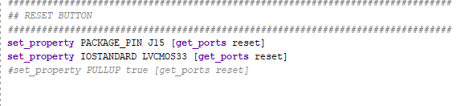
TODO: Add FPGA Screenshot showing the LED output

6. Bug Identification (0.5 mark)

Bug Identified / Explained / Fixed

TODO: Briefly describe the bug identified during evaluation
☑ Bug correctly identified
☑ Explanation and fix provided
1. Added reset functionality in top_fpga.
2. Added Simple PC counter.

